CollectIQ — AWS Cost Model and Optimization Tips

Date: October 14, 2025

Purpose: Provide a detailed cost estimate for AWS services used in the CollectIQ Hackathon Project, along with cost-saving tips for both hackathon and venture scale.

# 1. AWS Cost Model Overview

This model outlines approximate monthly costs for each AWS service used in CollectIQ at hackathon scale. All estimates are based on public AWS pricing data and assume moderate usage under free-tier limits where applicable.

|  |  |  |  |  |
| --- | --- | --- | --- | --- |
| Service | Pricing Basis | Estimated Usage | Monthly Estimate (USD) | Notes |
| AWS Lambda | $0.0000167 per GB-sec + $0.20 per 1M requests | 100k invocations, 512MB, 200ms avg | $5–10 | Free tier covers 1M req + 400k GB-s |
| API Gateway (HTTP API) | $1.00 per 1M requests | 100k calls | $1–3 | HTTP API cheaper than REST API |
| AWS Step Functions | $0.000025 per state transition | 80k transitions | $2 | Free 4k transitions included |
| Amazon Rekognition | $1 per 1,000 images | 10k images | $5–20 | Depends on feature usage (OCR, labels) |
| Amazon Bedrock | $0.035 per 1k node transitions | 20k agent calls | $0.70–2 | Token costs vary by model |
| Amazon DynamoDB | $1.25 per million writes / $0.25 per million reads | Low traffic (10k ops) | $2–5 | May fit within free tier |
| Amazon S3 | $0.023 per GB + $0.005 per 1k PUT/GET | 2GB, 10k images | <$1 | Low-cost storage tier |
| Amazon CloudWatch / X-Ray | $0.50/GB logs + metrics costs | Moderate logs | $2–5 | Control verbosity for cost savings |
| Amazon Cognito | $0.0055 per MAU over free tier | 500–1000 MAU | $0–2 | Usually negligible under 50k MAU |

**Total Hackathon Estimate:** Approximately $20–50/month, depending on API usage and free-tier utilization.

# 2. Cost Optimization Tips (Hackathon Phase)

• Stay under AWS free-tier limits for Lambda, Step Functions, DynamoDB, and S3.

• Use small Lambda memory allocations (256–512 MB).

• Reduce log verbosity; disable debug logs in production mode.

• Stub or mock Bedrock/Rekognition calls in development to avoid API costs.

• Use Express Step Functions instead of Standard for short workflows.

• Delete or disable unused resources and environments.

• Set AWS Budgets and alerts at $20–30 threshold to catch overages early.

• Batch operations and cache repeated API requests.

• Turn off monitoring or CloudWatch dashboards not essential during testing.

# 3. Cost Optimization Tips (Venture / Production Scale)

As CollectIQ scales beyond hackathon usage, apply these strategies for cost efficiency and sustainable growth:

• Use Bedrock model selection wisely — choose smaller or cheaper models for frequent tasks.

• Batch API calls and implement response caching for common cards.

• Apply Compute Savings Plans for Lambda workloads to reduce cost by up to 17–30%.

• Switch from DynamoDB on-demand to provisioned or autoscaling capacity as usage stabilizes.

• Archive old data (historic valuations, logs) into S3 Glacier Deep Archive for 90% savings.

• Use CloudWatch metric filters and sampled traces to reduce log ingestion volume.

• Monitor Bedrock token consumption; shorten prompts and reuse context.

• Enable cost tagging and resource groups to track environment-specific costs.

• Use Express Step Functions for high-volume workflows; limit retries.

• Use Cost Anomaly Detection and Billing Alarms for proactive monitoring.

• Periodically review IAM and remove unused resources to prevent idle costs.

# 4. Long-Term Financial Planning and Scaling Scenarios

Assuming CollectIQ grows to 10k active users with 100k scans per month, projected AWS infrastructure costs would likely reach $400–700/month, depending on model usage and concurrency. Scaling beyond 100k users may push infrastructure costs toward $1,500–2,000/month, mainly from AI inferences (Bedrock/Rekognition). Adopting cost optimization, caching, and model distillation strategies could reduce this by 30–40%.

Suggested cost ceiling milestones:

• MVP (Hackathon): $50/month

• Closed Beta (500 users): $250/month

• Public Launch (5,000 users): $700/month

• Growth Stage (50,000+ users): $1,500–2,000/month with Bedrock optimization

# 5. References

• AWS Lambda Pricing: https://aws.amazon.com/lambda/pricing/

• AWS Step Functions Pricing: https://aws.amazon.com/step-functions/pricing/

• Amazon Rekognition Pricing: https://aws.amazon.com/rekognition/pricing/

• Amazon Bedrock Pricing: https://aws.amazon.com/bedrock/pricing/

• DynamoDB Pricing: https://aws.amazon.com/dynamodb/pricing/

• Amazon S3 Pricing: https://aws.amazon.com/s3/pricing/

• Amazon CloudWatch Pricing: https://aws.amazon.com/cloudwatch/pricing/

• Amazon Cognito Pricing: https://aws.amazon.com/cognito/pricing/

• AWS Cost Optimization Guides: https://aws.amazon.com/architecture/cost-optimization/

# 6. Projected AWS Cost Visualization

The chart below visualizes projected AWS monthly costs for CollectIQ as it scales from Hackathon prototype to Growth stage. These figures represent conservative estimates based on model usage, data throughput, and compute costs.

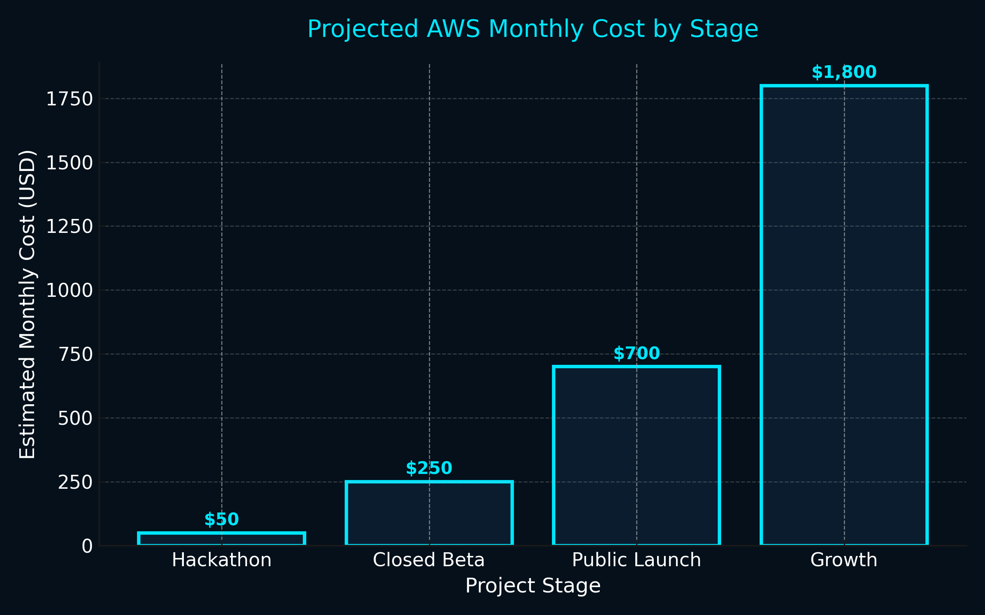

Interpretation: The transition from Hackathon to Growth represents roughly a 35× increase in compute and AI inference usage. However, implementing cost optimization measures (e.g., caching, token reduction, workload consolidation) can reduce this by 30–40%. These strategies will be critical for maintaining profitability and operational efficiency at scale.